Android devices have a special lock screen with a 3 x 3 grid of dots. Users can set an "unlock pattern" by connecting the dots in a specific sequence, forming a series of joined line segments where each segment's endpoints are two consecutive dots in the sequence. A sequence of k dots is a **valid** unlock pattern if both of the following are true:

* All the dots in the sequence are **distinct**.
* If the line segment connecting two consecutive dots in the sequence passes through any other dot, the other dot **must have previously appeared** in the sequence. No jumps through non-selected dots are allowed.

Here are some example valid and invalid unlock patterns:

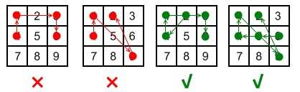

* The 1st pattern [4,1,3,6] is invalid because the line connecting dots 1 and 3 pass through dot 2, but dot 2 did not previously appear in the sequence.
* The 2nd pattern [4,1,9,2] is invalid because the line connecting dots 1 and 9 pass through dot 5, but dot 5 did not previously appear in the sequence.
* The 3rd pattern [2,4,1,3,6] is valid because it follows the conditions. The line connecting dots 1 and 3 meets the condition because dot 2 previously appeared in the sequence.
* The 4th pattern [6,5,4,1,9,2] is valid because it follows the conditions. The line connecting dots 1 and 9 meets the condition because dot 5 previously appeared in the sequence.

Given two integers m and n, return *the****number of unique and valid unlock patterns****of the Android grid lock screen that consist of****at least***m*keys and****at most***n*keys.*

Two unlock patterns are considered **unique** if there is a dot in one sequence that is not in the other, or the order of the dots is different.

**Example 1:**

**Input:** m = 1, n = 1

**Output:** 9

**Example 2:**

**Input:** m = 1, n = 2

**Output:** 65

**Constraints:**

* 1 <= m, n <= 9